
Department of Artificial Intelligence and Data Science
24ADI306 DEEP LEARNING

Assignment -3

Course Outcome(s): CO3
Bloom's Level: Apply & Analyze (K3–K4)
Title: Comparative Analysis of RNN, LSTM, and GRU for Sentiment Analysis
Objective: Implement and compare RNN, LSTM, and GRU models for sentiment classification.
Tasks:
• Select a sentiment analysis dataset.
• Perform text preprocessing (cleaning, tokenization, padding).
• Implement RNN, LSTM, and GRU models.
• Compare Accuracy, Precision, Recall, F1-score, and Training Time.
• Analyze the results and identify the best-performing model.
Deliverables:
• Jupyter/Colab Notebook
• Source Code
• Comparison Table
• 3–5 Page Report

Colab Link:
https://colab.research.google.com/drive/1MpTRKmL0xs2gKRjeT9mgRJox-MdIj3qr?usp=sharing
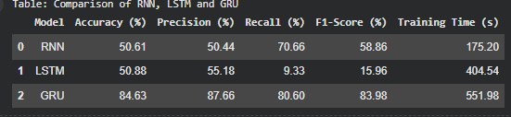
Assessment Rubric:
Criterion | Marks
Dataset preparation | 2
Model implementation | 5
Performance comparison | 4
Report | 4
Explanation | 5
Total | 20

